**DAILY ONLINE ACTIVITIES SUMMARY**

|  |  |  |  |  |  |  |  |
| --- | --- | --- | --- | --- | --- | --- | --- |
| **Date:** | **13/06/2020** | | | | **Name:** | **Anusha. K** | |
| **Sem & Sec** | **4th SEM 'A' Section** | | | | **USN:** | **4AL18CS009** | |
| **Online Test Summary** | | | | | | | |
| **Subject** | | **Data communication** | | | | | |
| **Max. Marks** | | **30** | | **Score** | | **23** | |
| **Certification Course Summary** | | | | | | | |
| **Course** | **Introduction to information security** | | | | | | |
| **Certificate Provider** | | | **greatlearning academy** | **Duration** | | | **5.5 hours** |
| **Coding Challenges** | | | | | | | |
| **Problem statement 1: Write a C Program to calculate Electricity Bill.**  **Problem statement 2: How to find the first non repeated character of a given String?** | | | | | | | |
| **Status:completed** | | | | | | | |
| **Uploaded the report in Github** | | | | **yes** | | | |
| **If yes Repository name** | | | | [**https://github.com/anusha20219/Lockdown-coding**](https://github.com/anusha20219/Lockdown-coding) | | | |
| **Uploaded the report in slack** | | | | **yes** | | | |

ONLINE TEST DETAILS: DC test was conducted fromfrom2:00 pm to 02:30pm.There were 15 questions and time assigned was 40 minutes. The questions were mcq type.

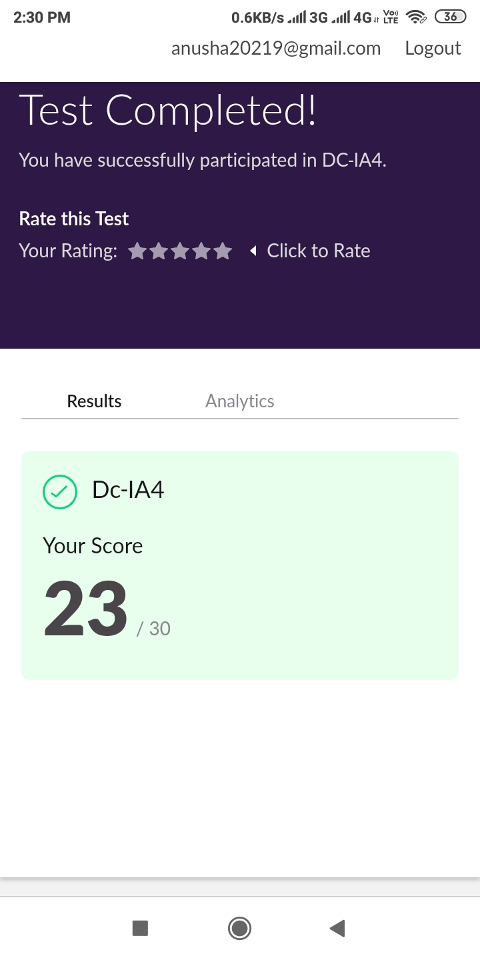

**Certification course details:**

**Today I** completed introduction to information security certification course by covering the topics security lessons from Big name breaches, hash, hack, code: emerging trends in cybersecurity. Then I attend the quiz and got certificate.

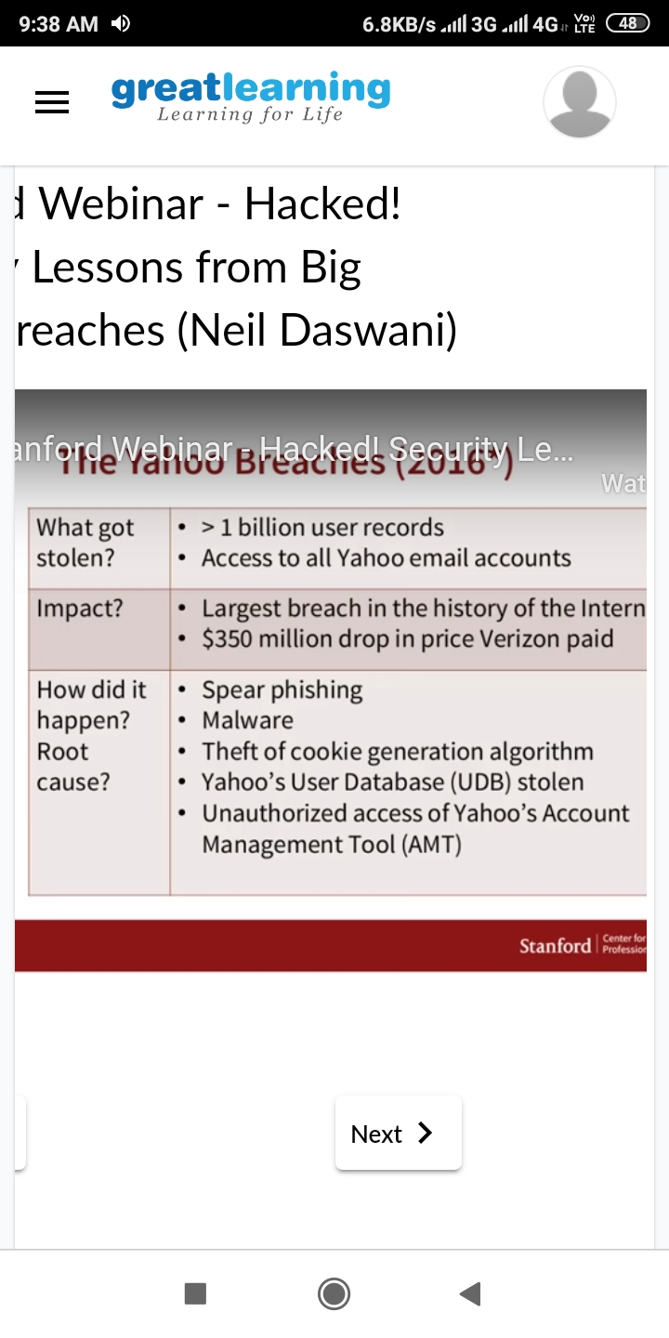**Coding challenge details:**

**Problem statement:1Write a C Program to calculate Electricity Bill**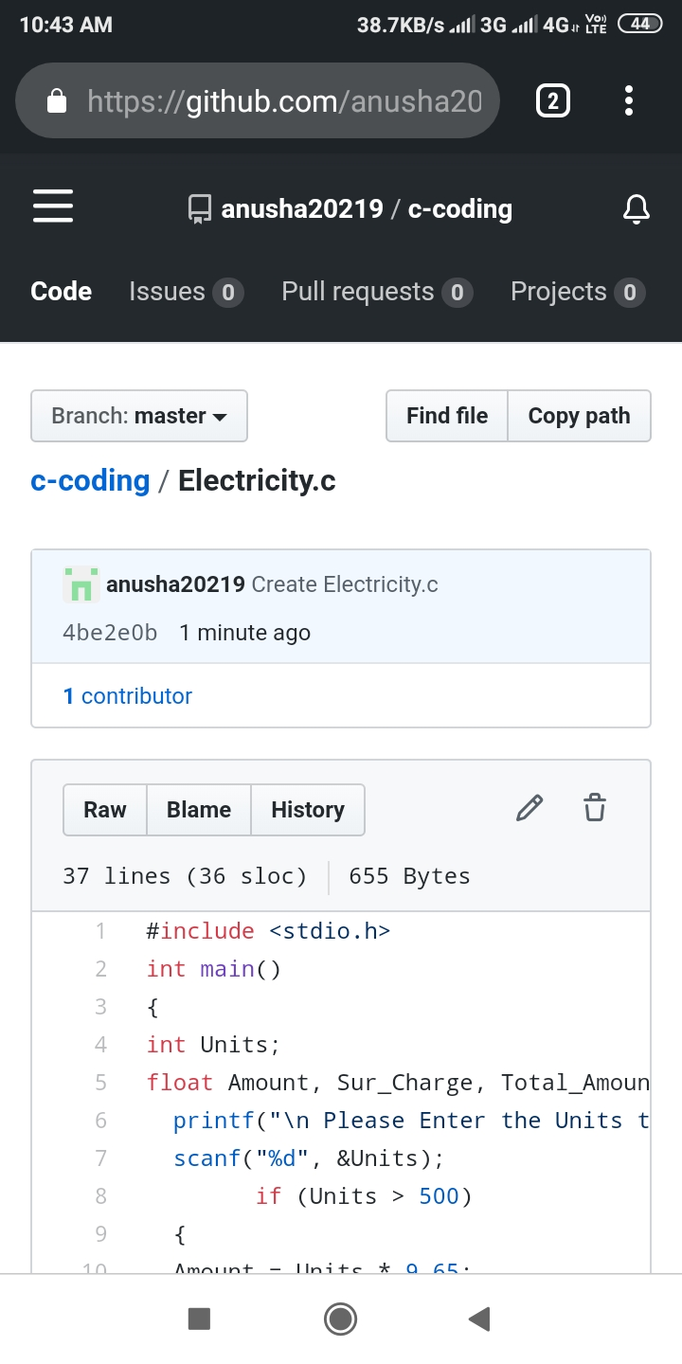

Problem statement: How to find the first non repeated character of a given String?

